From Custom Object “MTech Devices” page, click on ‘Start Sync Process’ button.

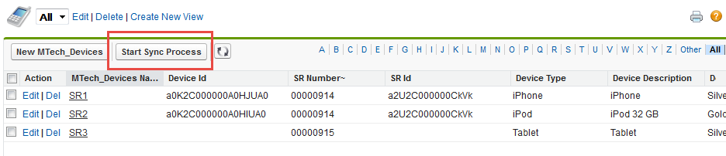

Page will open where you select Service Request Number of which you want to synch Devices. Once you select Service Request number from dropdown, you can see related Devices for that Service Request. If you want to continue with sync process, click on “Sync” button to sync all Devices.

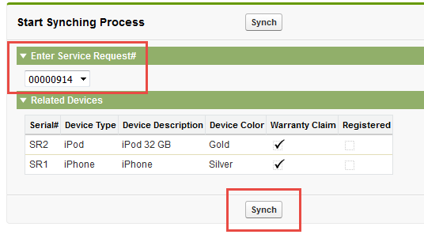

Device Synchronization process involves

* Registering new Devices in CMDB
* Creating Tasks